**CALLBACK FUNCTION**

There are three types of callback function

1 Tensorboard callback

2 Early stopping

3 Model checkpoint callback function

These will fit on the model.fit and will used as parameter

Tensorboard callback provdes interface which provides interactive interaction

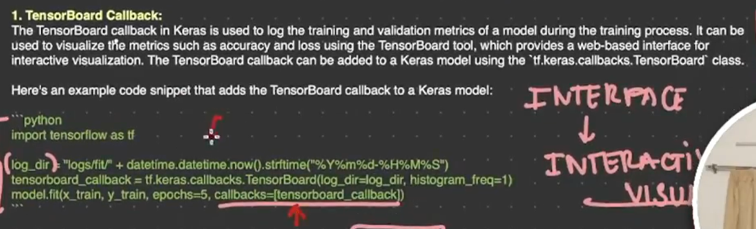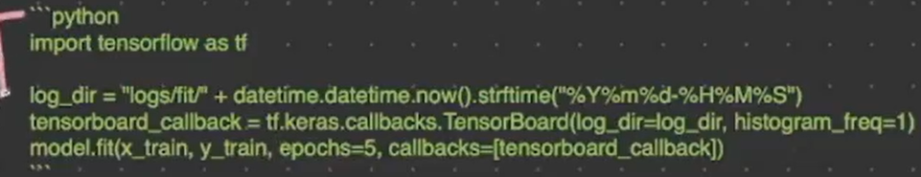

Code snippets

